Assignment-15.4:

Build and Deploy Hadoop word count program using Maven:

I am creating a Maven Project named Hadoop and in the src/main/java folder, I am creating the Wordcount class. Also I am attaching the WordCount.java and pom.xml files for your reference.

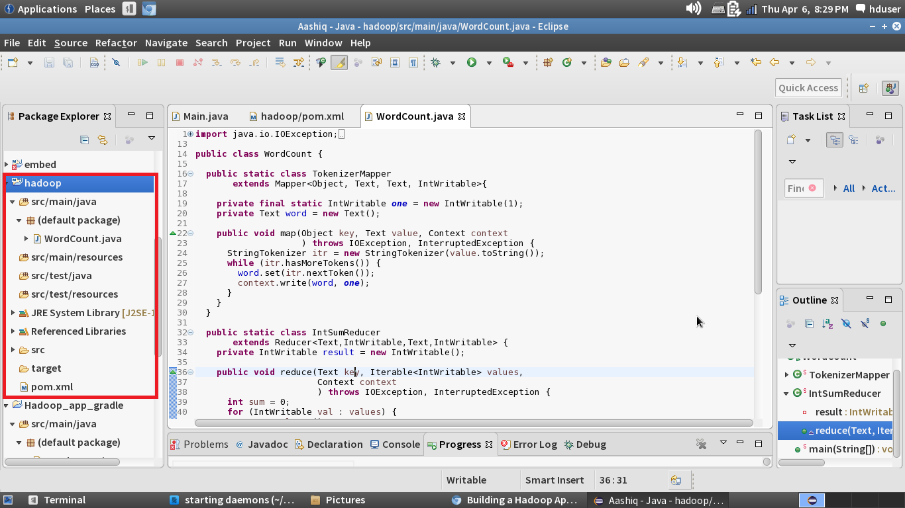

Tree Diagram: After Creating the maven project the pom.xml file is created

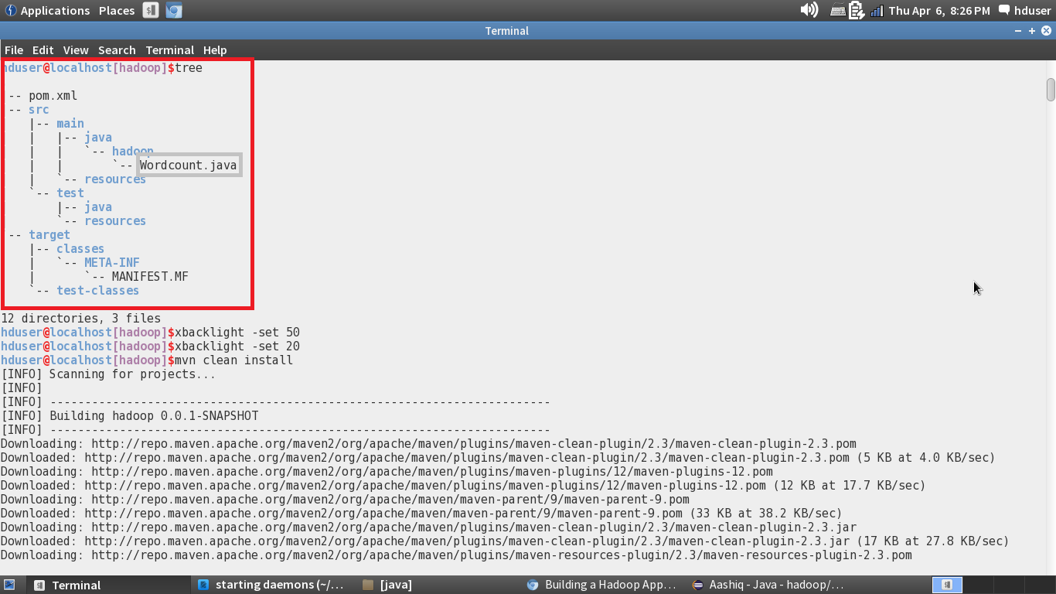

Adding the dependencies to the Pom.xml:

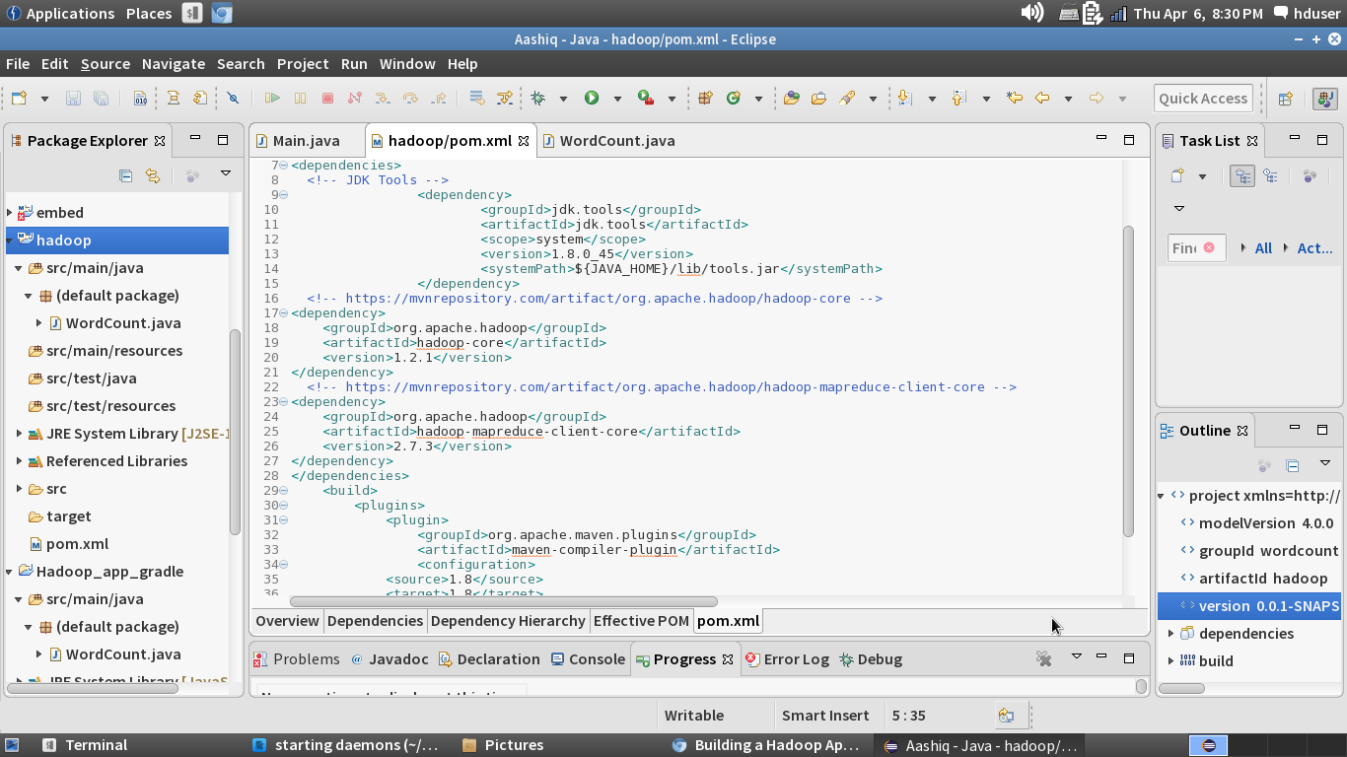

Building the project by giving the mvn clean install in the project folder:

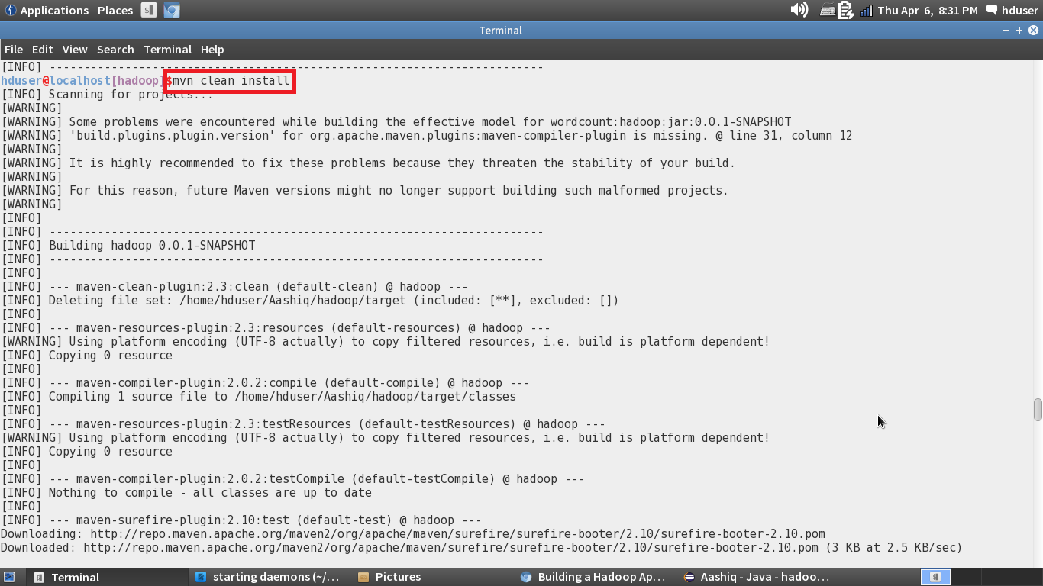

Project successfully build message:

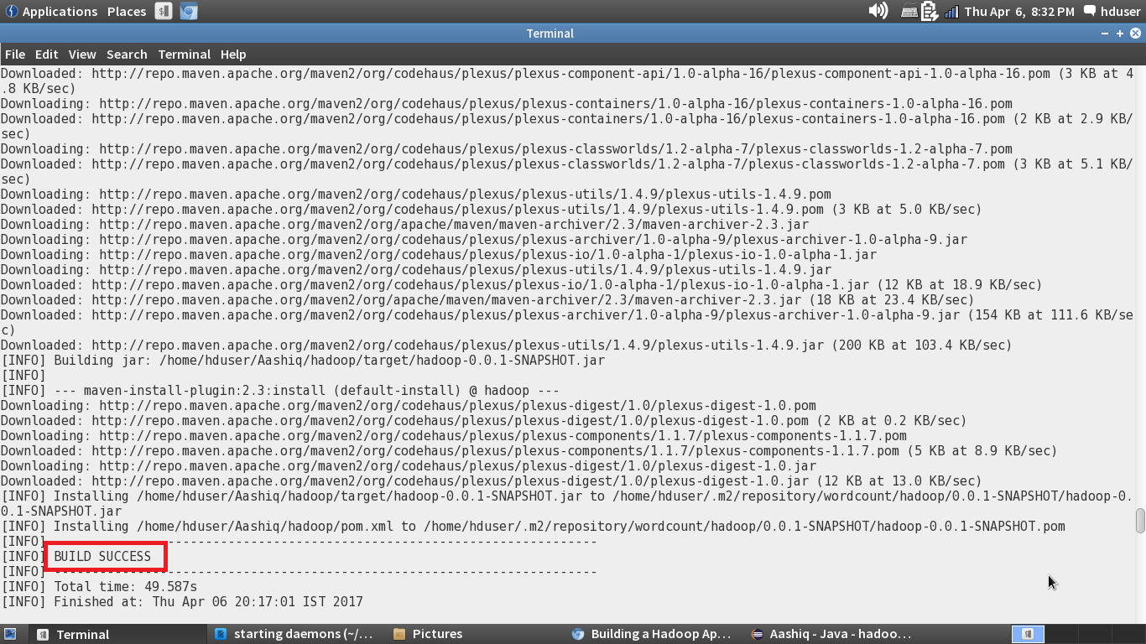

Snapshot.jar file created after the Build:

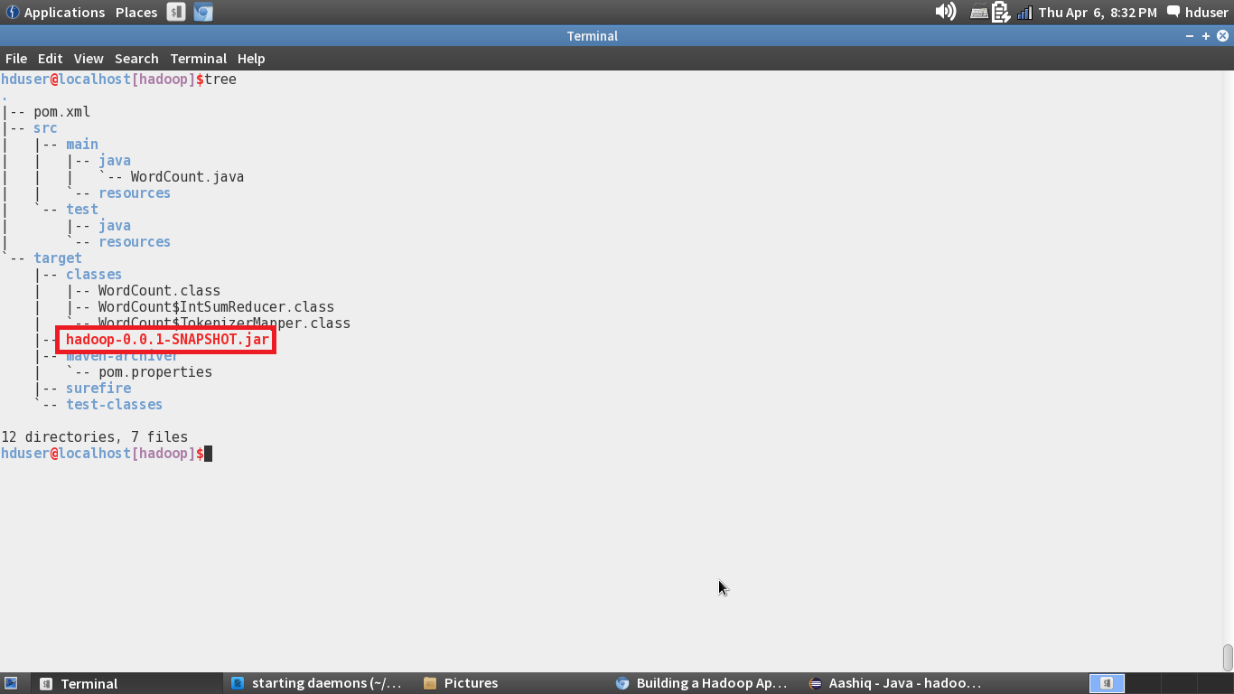

Running the Snapshot.jar file:

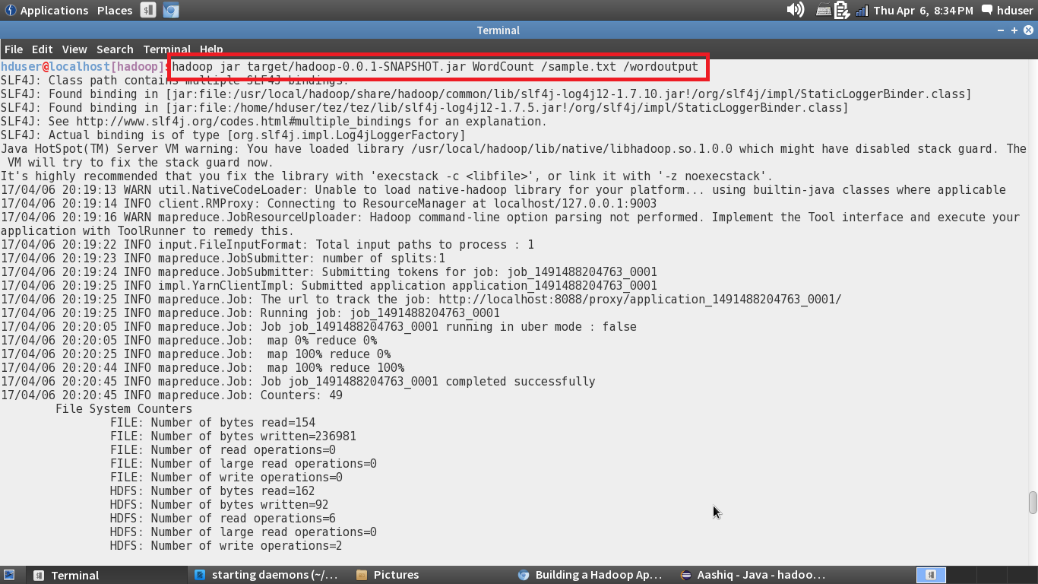

WordCount Output:

